The purpose of this document is to set out the Shamley Green Village Hall Health and Safety Policy and Information
Reference has been made to the Surrey Community Action as a source of guidance as to what is required. This recommends that we should have:
- Health and Safety Policy Document
- Risk assessment surveys and records
- Accident book
- Hiring agreement which includes the health and safety policy, together with the fire evacuation procedures
- Notice of fire evacuation procedures
- Insurance Documents
- Electrical and Gas safety certificates
- Reporting of accidents, disease, and dangerous occurrences regulations 1995 (RIDDOR) forms
- An up-to-date list of contacts from which we can obtain expert advice and guidance.

It is important to note that Health and Safety legislation means that the Management Committee (‘MC’) has a duty of care to all users of the hall, be they volunteers, visitors, hirers, and contractors.
It is considered best practice for the MC to nominate one member as Safety Officer and the person is responsible for all Health and Safety Issues.

Shamley Green Village Hall Health and Safety Policy
This document is the Health and Safety Policy of the Shamley Green Village Hall, known as Arbuthnot Hall, The Green, Shamley Green, GU5 0UA.
Our Policy is to provide healthy and safe working conditions, equipment and systems of work for our volunteers, visitors, hirers, and contractors and to provide all such training and information as is necessary.
We also accept responsibility for other people who may be affected by our activities, including all users of the Hall and contractors who may work there.
It is the intention of the Shamley Green Village Hall MC to comply with Health and Safety Legislation and to act positively where it can to prevent injury, ill health or any danger or loss arising from activities and operations.
Shamley Green Village Hall MC considers the promotion of the Health and Safety of all who may be affected by its activities and operations to be of essential importance. The MC recognises that the effective prevention of accidents depends as much on a committed attitude of mind to safety as on the operation and maintenance of equipment and safe systems of work. To this end it will seek to encourage participation in the establishment and observance of safe working practices.
All volunteers, visitors, hirers, and contractors will be expected to recognise that there is a clear duty on them to exercise self-discipline and accept responsibility to do everything they can to prevent injury to themselves or others.
Signed on behalf of the Shamley Green Management Committee
Name: Jonathan Watson
Position: Chair
Date:31st December 2022

Organisation of Health & Safety
Responsibilities
The Shamley Green Village Hall MC has overall responsibility for Health and Safety in the Hall.
The person delegated by the MC to have day to day responsibilities for the implementation of this Policy is:
Ali Bull, Hall Manager,
Email: hall.manager@arbuthnothall.org
Tel: 07767687376
It is the duty of all MC Members, volunteers, visitors, hirers, and contractors to take care of themselves and others who may be affected by their activities and to cooperate with the management in making the building a safe and healthy one.
Should a MC member, volunteer, visitor, hirer, or contractor come across a health and safety problem in the Hall which cannot be rectified immediately, then the Hall Manager, as the person responsible for health and safety should be informed in order for the matter to receive attention.
This Policy is reviewed by the MC on an annual basis.
1) Fire Precautions and checks
Person with responsibility: Ali Bull, Hall Manager.
Local Fire Brigade: Surrey Fire Brigade, Dewlands Drive, Cranleigh, GU6 7AD.
TEL: 999 or 0345 600 9009
Checks:

 | Frequency | Date
Initial risk assessment: |  | 22/08/2022
Regular Risk assessment: | Annually
Maintenance and check of fire equipment and records: | Annually
Testing of Fire Equipment: | Annually
Compiling the Fire procedure and notices: | Annually
Completing a fire drill: | Annually
List of equipment and location, service date | As Required

2) Insurance
Public Liability Insurance/Buildings Risk Insurance/ Special Risks/ Trustee Insurance
Insurer: Zurich Insurance Limited
Policy Number: P/01/116659673
Next Expiry Date:24 June 2024
3) First Aid Reporting and Reporting of Accidents
The person responsible for first aid and the upkeep of the first aid box is: Ali Bull, Hall Manager
The First Aid box is located in the kitchen on the work surface
The Accident Book is kept in the kitchen on the shelf.
Ali Bull, Hall Manager should be informed about accidents and the removal of items of first aid:
Tel: 07767687376
Email: hall.manager@arbuthnothall.org
If they are not available, contact the Hall Chairman
Jon Watson
Tel: 01483 891902
Email: chair@arbuthnothall.org
Ali Bull, Hall Manager is responsible for completing all RIDDOR forms
4) Information
Ali Bull, Hall Manager is responsible for providing information to volunteers, visitors, hirers, and contractors to enable them to use the building safely.
5) Hirers
Safety within the Hall is the responsibility of the MC, who must ensure that volunteers, visitors, hirers, and contractors abide by the guidelines for the Hall.
Hirers should read the Booking Form and The Conditions of Hire and the Health and Safety issues highlighted to them. They should then sign the form as evidence that they agree to the hiring conditions.
6) Contractors
Safety within the Hall is the responsibility of the MC, who must ensure that volunteers, visitors, hirers, and contractors abide by the guidelines for the Hall.
The MC and or the Hall Manager will always check with contractors before they start work that:
- the contract is clear and understood by both the contractor and the committee member/ Hall Manager
- the contractors are competent to carry out the work (i.e., qualifications/certification etc)
- the contractor has adequate public liability insurance cover
- the contractor has their own Health and Safety policy for their staff
- the MC/ Hall Manager will always check that the work required has been completed
7) Control of Substances Hazardous to health regulations
Ali Bull as Hall Manager is responsible for ensuring that all substances are handled correctly and stored safely. This includes paint and cleaning materials which should be locked away.
8) Risk Assessments & Inspections
Ali Bull as Hall Manager and Jon Watson as Chair are responsible for risk assessments and inspections.
Initial Risk assessment carried out by Ali Bull, Hall Manager and Jon Watson, Chair:
Date: 22/08/2022.
Risk assessments to be carried out:
Car Park | Weekly
Exterior of the Building incl. all lighting | Weekly
Entrance Area | Weekly
Toilets | Between Hires
Kitchen | Between Hires
Main Hall | Between Hires
Other rooms | Weekly
Fire Escapes | Between Hires
Electrical and Gas Installation | Monthly
9) Review of Health & Safety Policy
This Policy will be reviewed annually.
The Hall Manager will report at each MC on all Health and Safety matters and highlight any outstanding issues that require escalation for noting and agreement with regards action for remediation. If any matter is considered important, this should be immediately escalated to the Chair, who will advise the rest of the MC if appropriate.
Training will be provided to MC members and the Hall Manager on all matters relating to Health and Safety as appropriate.

10) Contact points
Shamley Green Village Hall known as Arbuthnot Hall
Ali Bull (Hall Manager) - Tel: 07767687376; Email: hall.manager@arbuthnothall.org
Jon Watson (Hall Chairman) - Tel: 01483 891902; Email: chair@arbuthnothall.org
Gillian Morris (Hall Treasurer) – Tel: 07399100109 Email: treasurer@arbuthnothall.org

NOTICE OF PROCEDURE IN CASE OF FIRE
If you discover a Fire
1. Shout Fire! Fire! Fire!
2. Go to the assembly point by the Cricket Square on the Green
3. Call the Fire Brigade on 999, if you cannot get mobile reception go to the Shamley Green Village Stores on the eastern corner of the green or Red Lion Pub across the green to use their phone to raise the alarm. The Address of the Hall is: Shamley Green Village Hall, known as Arbuthnot Hall, The Green, Shamley Green, GU5 0UA.
ON HEARING THE FIRE ALARM
1. Leave the building by the quickest available route, noting there are designated Fire Exits at the main entrance, in the bar area, and to the right of the stage at the back of the kitchen.
2. Go to the place of the assembly on the Cricket Square on the Green, the hirer should ensure all parties with limited mobility/ disability are assisted to vacate the building.
3. Do not leave the assembly point until told to do so by the hirer.
4. Do not return to the building until told to do so by the hire.
Location of Fire Exits, Extinguishers and Escape Routes.
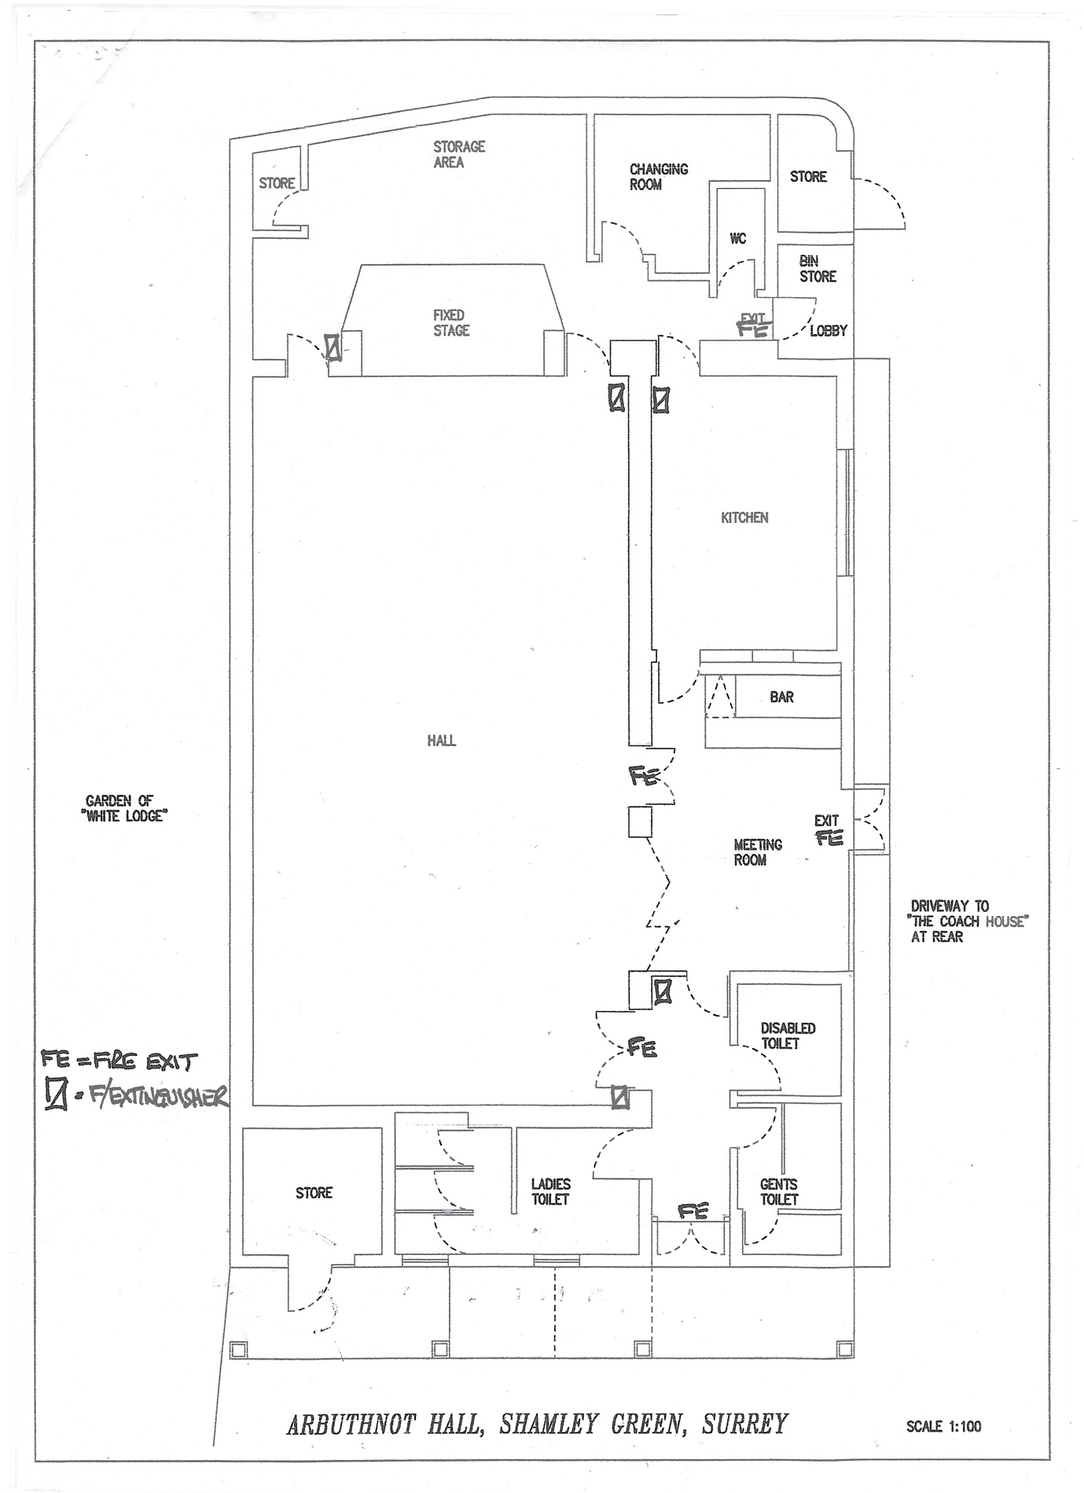

Health and Safety Risk Assessment Document
In compiling this document a ‘Risk Assessment’ is completed in order that potential hazards and risks to MC members, volunteers, visitors, hirers, and contractors of the premises might be identified.
Basic guidelines covering methods of conduct and courses of action have therefore been developed and are detailed below.
The inherent requirement is that all concerned MC members, volunteers, visitors, hirers, and contractors should be aware of their legal and moral obligations in relation to the need to follow good practice in all aspects of Health and Safety, and they should be aware of their responsibilities under the appropriate Health and Safety Legislation. Simply put, this requires that everyone adopts and practises a common sense and responsible attitude towards Health and Safety.
Particular attention should be given to the following:
- Risk of electric shock from portable electrical equipment and/or damaged or dangerously exposed parts of the general electrical installation
- Risk of electrical shock caused by the operation of the main electrical switch gear.
- Risk of slipping on stairs, polished or wet floors.
- Risk of accidents when using ladders inside or outside the building
- Risk of injury through incorrect lifting/moving of heavy or bulky items, including tables and chairs.
- Inadequate use of artificial lighting.
- Risk to any person while in sole occupancy of the building.
- Risk involved in the handling, storage, and usage of cleaning or similar materials which may be toxic or generally dangerous.
- Risks involved in handling or using kitchen equipment e.g., Knives, water heaters gas stove etc

Adoption of the following practises will minimise these and other potential risks.
- Make sure that all emergency exit doors are clear and unlocked as soon as the hall is to be used.
- Do not operate or touch any electrical equipment where there are signs of damage, exposure of components or water penetration etc
- Do not work on steps or ladders until the same are properly secure and another person is present.
- Do not stand on chairs or other objects that are not designed to stand on.
- Do not leave portable electrical or gas appliances operating unattended.
- Do not allow unaccompanied children in the kitchen area.
- Do report any evidence of damage, potential damage or misuse of the Hall structure and/or contents and facilities to Ali Bull, the Hall Manager, or if unavailable Jon Watson, Chair.
- Do wear suitable protective clothing when handling/using cleaning or other similar toxic materials.
- Do report any items missing or used from the first aid box.
- Do report any accidents (whether or not resulting in injury or damage to person or property) to the above person(s) and ensure that all the relevant details are recorded.
Risk Assessment Form
Risk Assessments
There are 5 steps to Risk Assessments as defined by the Health and Safety Executive.
Look for hazards - Look for hazards which you could reasonably expect to result in harm
Decide who might be harmed and how - think about the groups of people who may be harmed and consider those who maybe more vulnerable.
Evaluate the risks and decide whether existing precautions are adequate or more should be done - Have you already taken precautions against the risks?
Record your findings
Review your assessment and revise if necessary - What more could reasonably be done?
These steps are thoroughly explained in the HSE publication ‘5 steps to risk assessment’
It is vital to record risk assessments and keep the records with dates, comments etc. It is recommended that one form is used for each area of the building.
When hazards have been highlighted it is important to agree how often the assessments will be repeated and recourse these events.
Area
Risks | Date Identified | Remediation/ Action | Action Owner | RAG | Action Date | Date Completed
Area Assessed:
Assessment undertaken by:
Date:
Hazard: Who might be harmed? Is the risk adequately controlled? What further action is necessary to control the risk?

